;l

Foundations of Programming

Assignment No. : 4
- PROBLEM STATEMENT: Write a C Program to calculate the salary of an employee given his basic pay (taken as input from the user). Calculate gross salary of employee. Let HRA be 10 % of basic pay and TA be 5% of basic pay. Let employees pay professional tax as 2% of total salary. Calculate net salary payable after deductions.

OBJECTIVE:

- To understand the importance of flowchart for any programming model.
- To learn simple flowchart symbols and arrows to define relationships.
- To understand and develop visual representations of flow of data.

THEORY:
- Define Algorithm.
- What are the different characteristics of an algorithm.
PLATFORM: Linux
ALGORITHM:
1.Start.
2.Declare variables: basic_pay, hra, ta, gross, tax, net_pay.
3.Read basic_pay from the user.
4.Calculate hra = 0.10 * basic_pay.
5.Calculate ta = 0.05 * basic_pay.
6.Calculate gross = basic_pay + hra + ta.
7.Calculate tax = 0.02 * gross.
8.Calculate net_pay = gross - tax.
9.Display hra, ta, gross, tax, and net_pay (or at least net_pay).
10.Stop.
FLOWCHART:
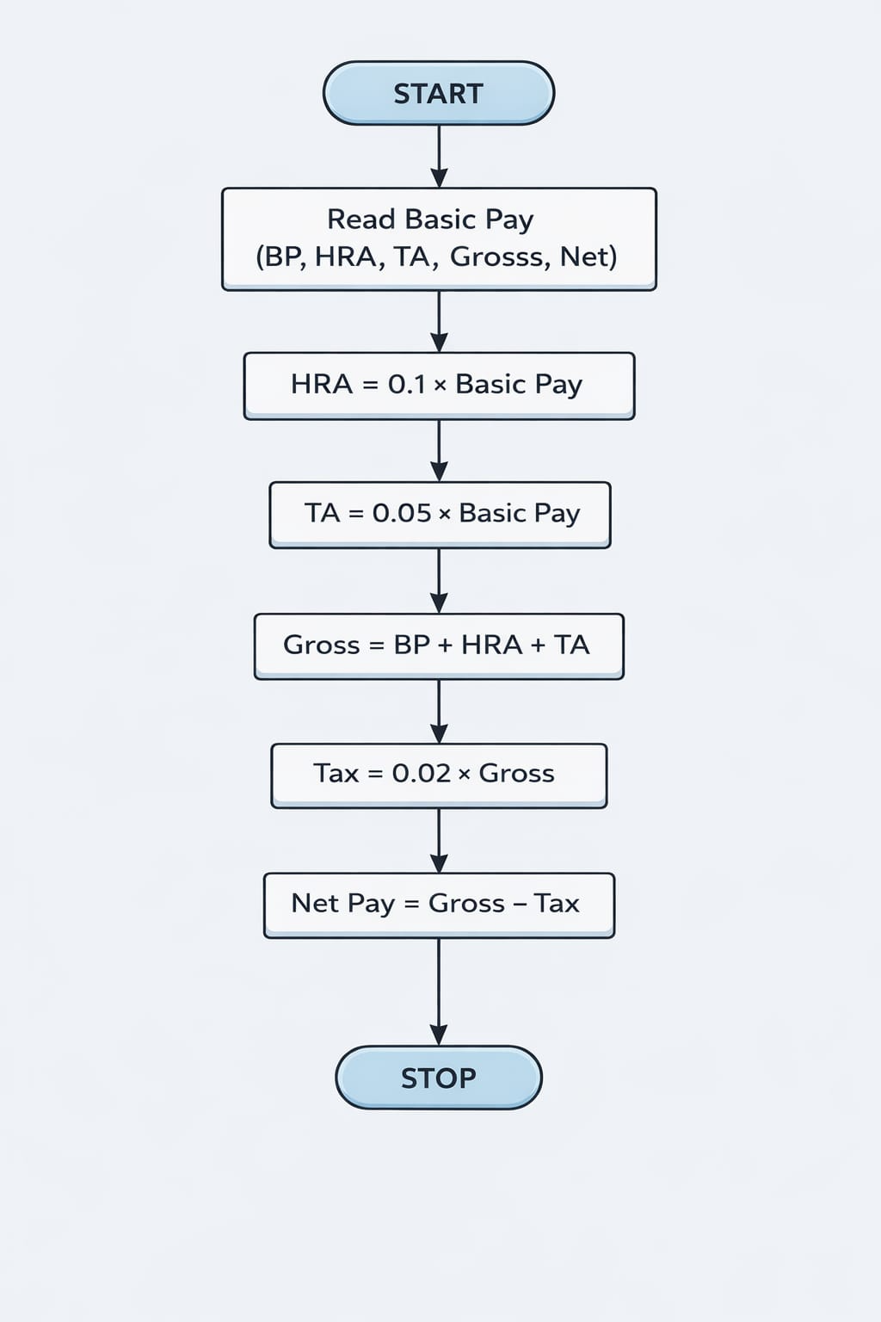

INPUT:
#include <stdio.h>

int main() {

float basic_pay;

printf("Enter your basic pay:");
scanf("%f", &basic_pay);

float hra, ta, tax, gross, netpay;

hra = 0.1 * basic_pay;
tax = 0.02 * gross;
gross = basic_pay + hra + ta;
netpay = gross - tax;
ta = 0.05 * basic_pay;

printf("The net salary of employee is %f", netpay);

return 0;
}

OUTPUT:
Enter your basic pay:3300
The net salary of employee is 3630.000000

CONCLUSION: Thus, we have learned to write algorithms and to draw its representation in terms of flowchart.

FAQs:
- Describe various symbols and their use in flowchart.
- Difference between Algorithm and Flowchart.

